Lecture#21 Form Validation,Drawer

Objectives
- Form Validation
- Drawer

Form Validation:
In Flutter, you can perform form validation by wrapping your input fields in a Form widget and defining validation rules for each field using the validator property of the TextFormField widget. This property takes a function that receives the input value and returns an error message if the value is invalid or null if the value is valid. Once the user submits the form, you can call the validate method of the Form widget to check if all the input values are valid.
Here is an example of how to implement a Form Validation in Flutter:

import 'package:flutter/material.dart';

void main() => runApp(MyApp());

class MyApp extends StatelessWidget {
@override
Widget build(BuildContext context) {
return MaterialApp(
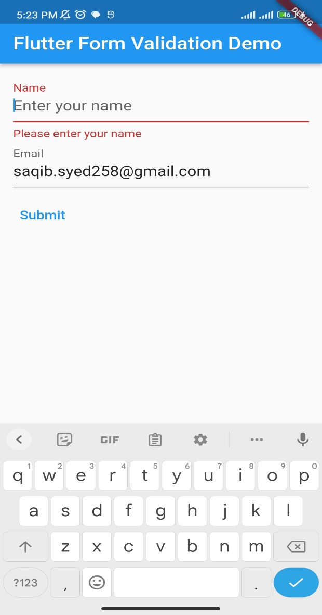
title: 'Flutter Form Validation Demo',
theme: ThemeData(
primarySwatch: Colors.blue,
),
home: MyForm(),
);
}
}

class MyForm extends StatefulWidget {
@override
_MyFormState createState() => _MyFormState();
}

class _MyFormState extends State<MyForm> {
final _formKey = GlobalKey<FormState>();

String? _name;
String? _email;

@override
Widget build(BuildContext context) {
return Scaffold(
appBar: AppBar(
title: Text('Flutter Form Validation Demo'),
),
body: Padding(
padding: EdgeInsets.all(16.0),
child: Form(
key: _formKey,
child: Column(
crossAxisAlignment: CrossAxisAlignment.start,
children: <Widget>[
TextFormField(
validator: (value) {
if (value!.isEmpty) {
return 'Please enter your name';
}
return null;
},
onSaved: (value) {
_name = value!;
},
decoration: InputDecoration(
labelText: 'Name',
hintText: 'Enter your name',
),
),
TextFormField(
validator: (value) {
if (value!.isEmpty) {
return 'Please enter your email';
}
if (!RegExp(r'^[\w-\.]+@([\w-]+\.)+[\w-]{2,4}$')
.hasMatch(value)) {
return 'Please enter a valid email';
}
return null;
},
onSaved: (value) {
_email = value!;
},
keyboardType: TextInputType.emailAddress,
decoration: InputDecoration(
labelText: 'Email',
hintText: 'Enter your email',
),
),
Padding(
padding: EdgeInsets.symmetric(vertical: 16.0),
child: TextButton(
onPressed: () {
if (_formKey.currentState!.validate()) {
_formKey.currentState!.save();
showDialog(
context: context,
builder: (BuildContext context) {
return AlertDialog(
title: Text('Form Submitted'),
content: SingleChildScrollView(
child: ListBody(
children: <Widget>[
Text('Name: $_name'),
Text('Email: $_email'),
],
),
),
actions: <Widget>[
TextButton(
child: Text('OK'),
onPressed: () {
Navigator.of(context).pop();
},
),
],
);
},
);
}
},
child: Text('Submit'),
),
),
],
),
),
),
);
}
}

Drawer:

import 'package:flutter/material.dart';

void main() => runApp(MyApp());

class MyApp extends StatelessWidget {
@override
Widget build(BuildContext context) {
return MaterialApp(
title: 'Drawer Example',
home: MyHomePage(),
);
}
}

class MyHomePage extends StatelessWidget {
@override
Widget build(BuildContext context) {
return Scaffold(
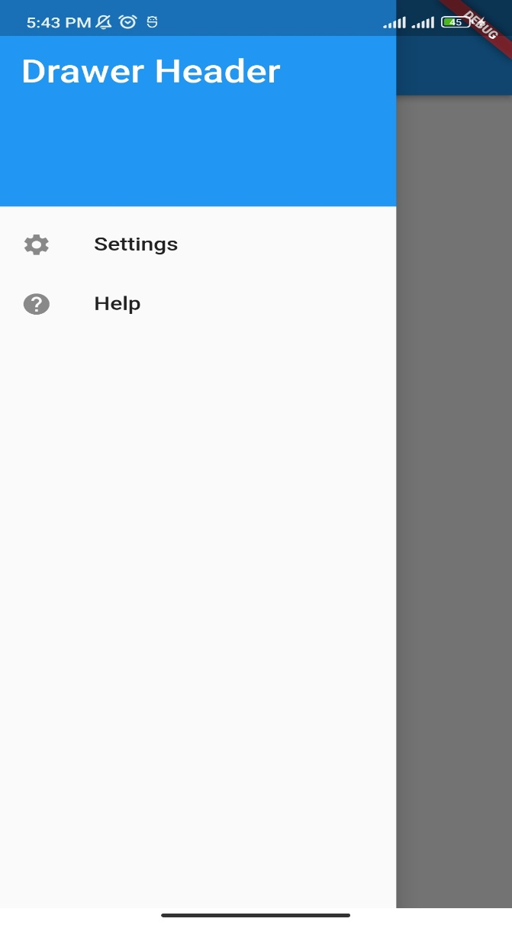
appBar: AppBar(
title: Text('Drawer Example'),
),
drawer: Drawer(
child: ListView(
padding: EdgeInsets.zero,
children: <Widget>[
DrawerHeader(
decoration: BoxDecoration(
color: Colors.blue,
),
child: Text(
'Drawer Header',
style: TextStyle(
color: Colors.white,
fontSize: 24,
),
),
),
ListTile(
leading: Icon(Icons.settings),
title: Text('Settings'),
onTap: () {
// do something
Navigator.pop(context);
},
),
ListTile(
leading: Icon(Icons.help),
title: Text('Help'),
onTap: () {
// do something
Navigator.pop(context);
},
),
],
),
),
body: Center(
child: Text('My App'),
),
);
}
}

In this example, the Drawer widget is added to the Scaffold as the drawer property. The Drawer widget contains a ListView with a DrawerHeader widget and two ListTile widgets. When the user taps on a ListTile, the Navigator.pop(context) method is called to close the Drawer.

Lecture#22 Drawer with Image Picker

Objectives
- Drawer
- Image Picker(Gallery,Camera)

Dependency: image_picker: any

Drawer and Image Picker:

import 'dart:io';
import 'package:flutter/material.dart';
import 'package:image_picker/image_picker.dart';

void main() => runApp(MyApp());

class MyApp extends StatelessWidget {
@override
Widget build(BuildContext context) {
return MaterialApp(
title: 'Drawer Example',
home: MyHomePage(),
);
}
}

class MyHomePage extends StatefulWidget {
@override
_MyHomePageState createState() => _MyHomePageState();
}

class _MyHomePageState extends State<MyHomePage> {
File? _image;

void getImage(ImageSource source) async {
final pickedFile = await ImagePicker().pickImage(source: source);

setState(() {
if (pickedFile != null) {
_image = File(pickedFile.path);
} else {
print('No image selected.');
}
});
}

@override
Widget build(BuildContext context) {
return Scaffold(
appBar: AppBar(
title: Text('Drawer Example'),
),
drawer: Drawer(
child: ListView(
padding: EdgeInsets.zero,
children: <Widget>[
DrawerHeader(
decoration: BoxDecoration(
color: Colors.blue,
),
child: Column(
crossAxisAlignment: CrossAxisAlignment.start,
children: [
CircleAvatar(
radius: 40,
backgroundImage: _image != null ? FileImage(_image!) : null,
child: _image == null
? Icon(
Icons.account_circle,
size: 50,
)
: null,
),
SizedBox(height: 8),
Text(
'Saqib Hussain',
style: TextStyle(
color: Colors.white,
fontSize: 20,
),
),
SizedBox(height: 8),
],
),
),
ListTile(
leading: Icon(Icons.settings),
title: Text('Choose image'),
onTap: () {
showDialog(
context: context,
builder: (BuildContext context) {
return AlertDialog(
title: Text("Choose source"),
actions: [
TextButton(
child: Text("Gallery"),
onPressed: () {
getImage(ImageSource.gallery);
Navigator.of(context).pop();
},
),
TextButton(
child: Text("Camera"),
onPressed: () {
getImage(ImageSource.camera);
Navigator.of(context).pop();
},
),
],
);
},
);
},
),
],
),
),
body: Center(
child: Text('My App'),
),
);
}
}

